Thear’s Salvation

*By group 12: Kaloyan Aleksiev and Kaloyan Madzhunov*

**Game platform:** PC

**Game story:** After years and years of planet Thear’s human population overexploiting the natural resources, the elements decided to take revenge. Earth, Fire, Air and Water have been turning humans into elemental monsters of their own kind. The Bandit organization has been stealing nature’s precious gifts and taking innocent people hostage in an attempt to reach their ultimate goal of ruling the whole planet. Ven took the mission to reestablish the harmony between man and nature by eliminating the Bandits and freeing the souls of the Elementals.

**Game play:** In this 2D adventure platformer with pixel art aesthetics, the player takes the persona of Ven - a brave boy on a mission to restore the planet’s balance. While wandering through the beautiful world of Thear, Ven encounters different elemental creatures. He must free the souls of the trapped people from the binding forces of nature by fighting the elemental creatures and collecting Soul Orbs that they drop when defeated. The vast and mesmerizing world of Thear also hides a plethora of mysteries and interesting collectibles and elemental swords that Ven can pick up in order to become stronger. On his adventure to calm the wrath of the elements, he also runs into the Bandits - an organization responsible for the chaos that has been happening. Ven has to defeat those criminals who drop different swords that Ven will need in order to stop their plans before it is too late. Only then Ven can restore the balance and save the world.

**Elevator pitch:** A 2D adventure platformer with pixel art aesthetics which has as a core concept the 4 elements - water, earth, fire, air. You are a brave character on a mission to save the world by using elemental swords to fight corrupt bandits who abuse the resources of the planet and elemental creatures which are ordinary people possessed by an elemental spirit. Your goal is to free the planet from the Bandits’ doom and calm the spirits of nature by releasing them from the elemental creatures.

**USP (Unique Selling Points):**

* Natural elements as a core concept
* Fast-paced 2D adventure platformer
* General message to protect the nature/environment
* Simple puzzle elements
* Eliminate all the Bandits and get their gear!
* Defeat the Elementals and release the humans!
* Collect Soul Orbs and upgrade your abilities!

**Similar competitive products:**

* Brawlhalla (inspired by the fighting and movement mechanics, item pickup, visual aesthetics - platforms and backgrounds)

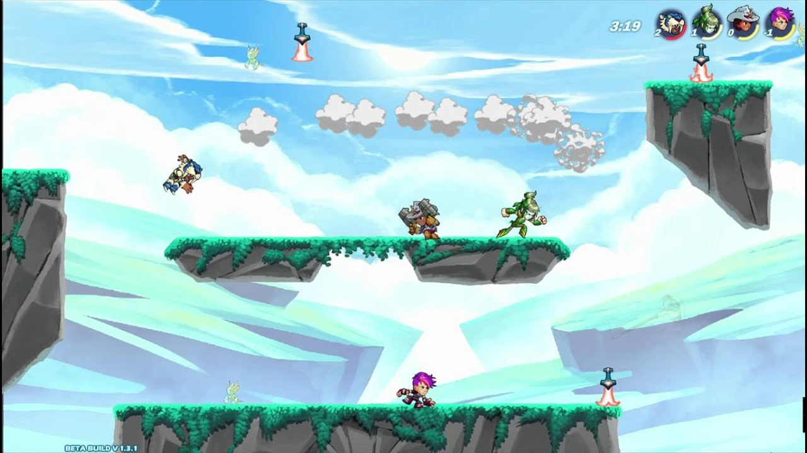

* Ori and the Blind Forest (inspired by the level design, puzzle element, game mood)

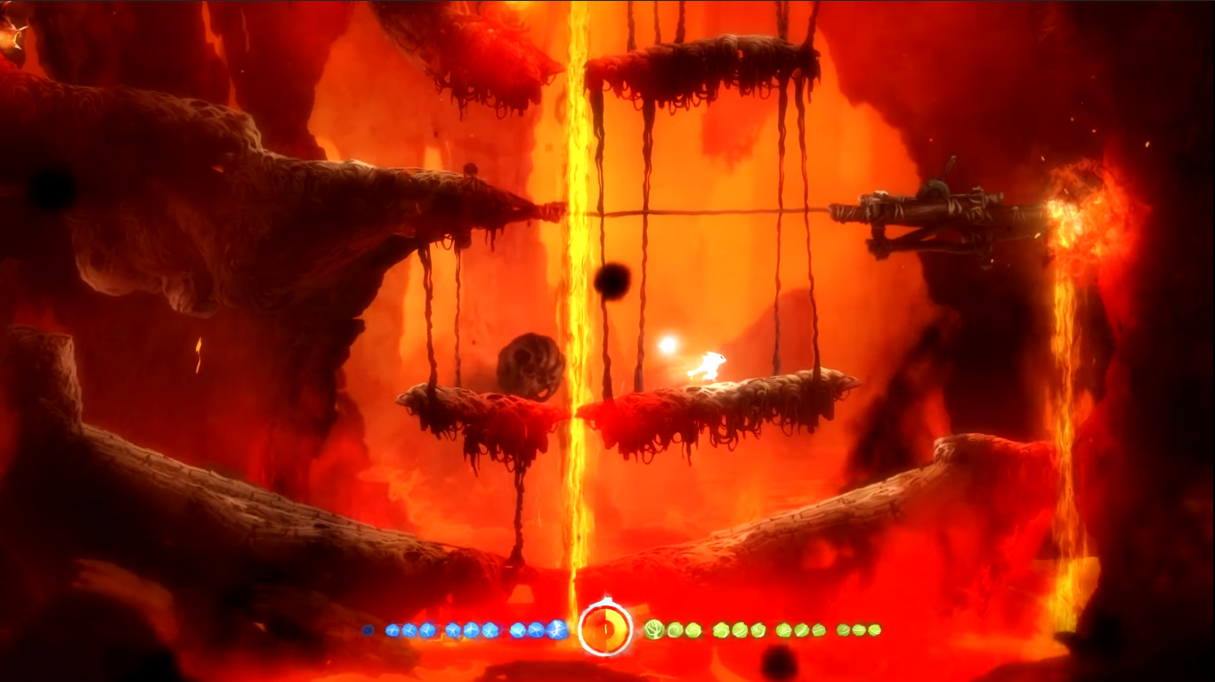

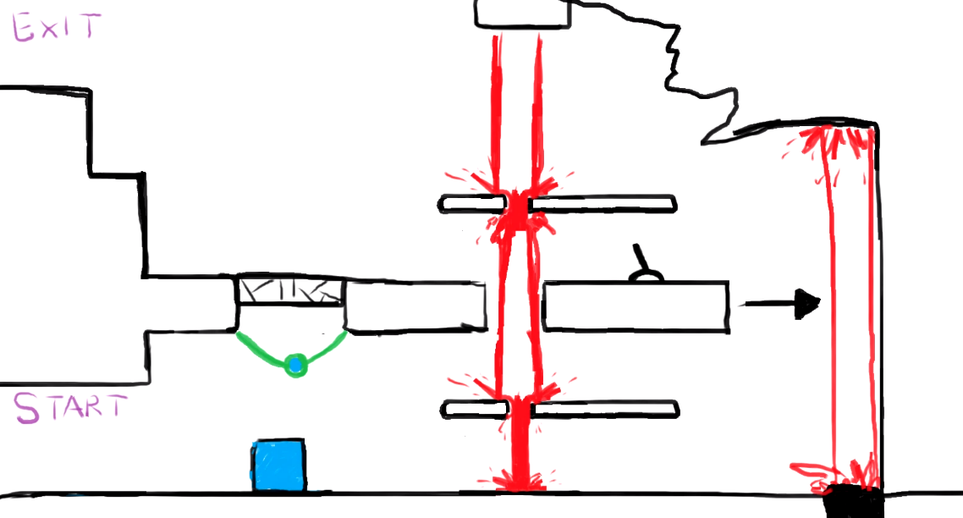

**Storytelling:** The story of the game will be introduced by small narrative segments supported by a voiceover while the player advances through the game. In this way the story is blended with the gameplay rather than, for instance, introducing the story by different cinematic screens. [Example](https://youtu.be/fQgmPJYUiqw?t=43)

**Player character:**

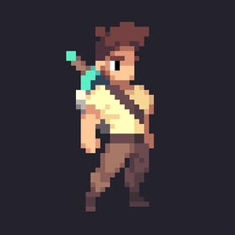

Ven; Player character example

* Stats:
  + 100 HP
  + Starts with 1 basic sword
* 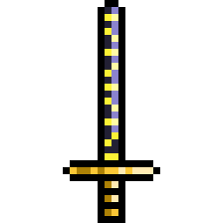Swords:
  + Basic Sword (low damage)
    - 30 dmg on hit
    - 1.0 attack speed (normal)
  + 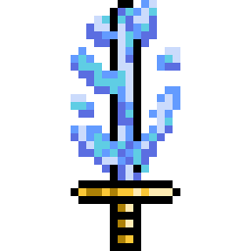Water Sword (slow effect)
    - 45 dmg on hit
    - the enemy gets slowed for 3 seconds upon being hit
    - 1.0 attack speed (normal)
    - 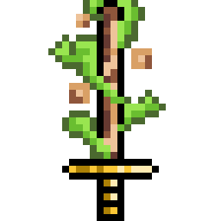strong against Fire, weak against Earth
  + Earth Sword (slow attack, a lot of damage)
    - 60 dmg on hit
    - 0.8 attack speed
    - strong against Water, weak against Air
  + 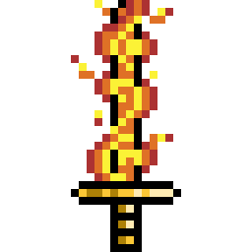Fire Sword (deals part of the damage on hit, inflicts burn effect after)
    - 40 dmg on hit
    - deals 30 dmg over 3 seconds on hit
    - 1.0 attack speed (normal)
    - strong against Air, weak against Water
  + 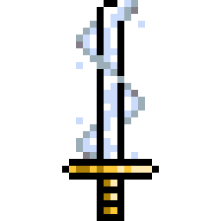Air Sword (fast attack, low to mid damage)
    - 35 dmg
    - 1.3 attack speed
    - strong against Earth, weak against Fire

The player starts with a basic sword. Over the course of the game, they can obtain different elemental swords by finding them throughout the level or by killing Bandits which might drop a random elemental sword upon dying. The player can choose in which playing style they want to develop the character’s skills. Upon being eliminated, each Elemental drops a single Soul Orb which can be used for upgrading the character’s powers:

* Health Boost - Adds 25HP to the player’s health, max +100HP (3 Soul Orbs)
* Ultra Defense - Reduces the damage inflicted by enemies by 10% of the player’s health, max +40% (3 Soul Orbs)
* Damage Enhance - Adds 5% to the damage dealt by the player on hit, max +20% (3 Soul Orbs)

Maxing each of the three skills requires 4 upgrades and 12 Soul Orbs per skill which makes in total 36 Soul Orbs that the player needs to collect in order to fully upgrade the character. Each Elemental drops a single Soul Orb. Therefore, there should be at least 36 elemental creatures in the game.

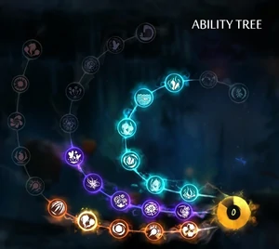

Soul Orbs upgrade system example

**Player controls:**

* Horizontal Movement - A/D
* Jump - Spacebar/W
* Crouch - Ctrl/S
* Regular Attack - LMB
* Interact/Pick up - E

**Game world:** The world of the game features backgrounds and platforms inspired by the four elements - water, earth, air and fire. It will have element-specific traits such as lava pools, magma platforms, thorn bushes, rocky platforms, water pools, geysers, floating platforms, windy sections, etc. The player can interact with the platforms in different ways - some can deal damage, some allow transportation, some can tweak the movement speed, etc.

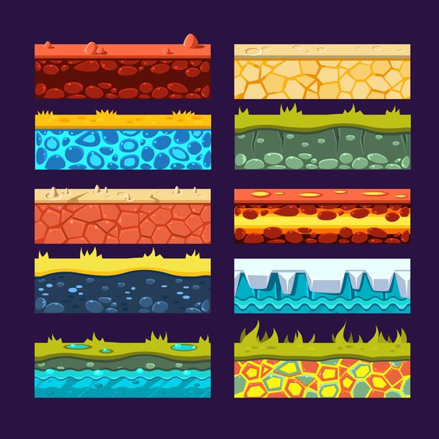

Element-based platforms example

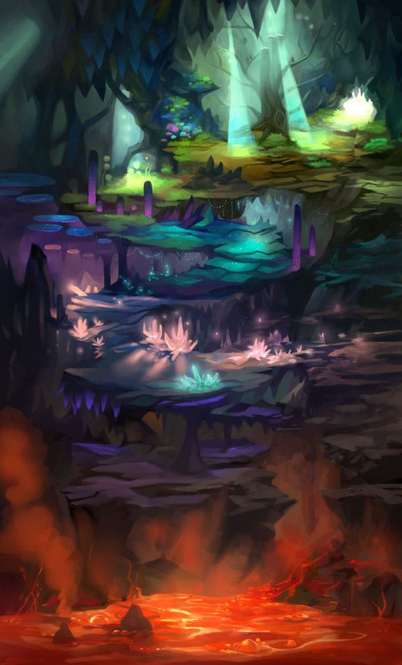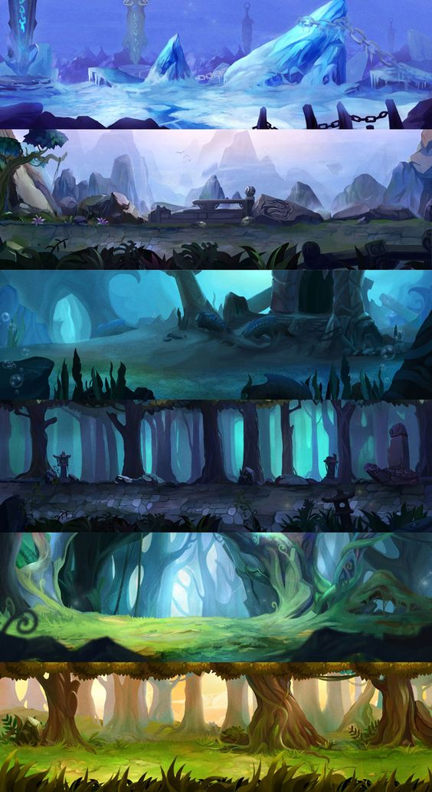

Element-based backgrounds example

**Game experience:** The player fights sneaky evil bandits that could drop powerful swords based on the four elements. The swords provide different playing experience but the player can pick up only one sword at a time. The player can choose which elemental sword they want to fight with but each element has a weak and a strong counterpart element - Water extinguishes Fire, Fire consumes Air, Air erodes away Earth, and Earth absorbs Water. The character’s abilities can be upgraded by spending collected Soul Orbs from killing elemental creatures which allows the player to explore the game in their own unique style.

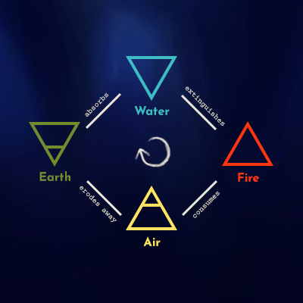

Elemental rock paper scissors concept

There are 3 separate ‘Game Pleasures’ in the game:

* Sensation - Each level’s element theme is supported by an appropriate background and platforms matching the element (e.g. burning cracks with lava in the Fire level, little blue watery cracks in the Water level, etc.)
* Challenge - The two different types of enemies in combination with the level design that requires creativity and problem-solving skills to complete make for a challenging feeling throughout the gameplay
* Expression - The player can choose between 4 different swords and 3 different character upgrades. This freedom of choice brings the feeling of expression in the game, since every player can choose a different path of development.

**Game mechanics:**

* **Must Have**
* Horizontal Movement - A/D
* Jump - Spacebar/W
* Crouch - Ctrl/S
* Regular Attack - LMB
* Interact/Pick up - E
* Collectibles: Soul Orbs - Elementals drop Soul Orbs when defeated. These Soul Orbs can be consumed to upgrade character stats, e.g. HP or Attack Damage.
  + [Skill tree concept](https://www.giantbomb.com/skill-tree/3015-382/)
  + [Ability tree (Ori and the Blind Forest)](https://oriandtheblindforest.fandom.com/wiki/Ability_Tree_(Ori_and_the_Blind_Forest))
* Elemental swords with different stats
* Character upgrades
* **Should Have**
* Double Jump - Spacebar x2
* Heavy Attack - RMB
* Wall sliding - After a jump toward a wall, the character has a short timespan in which they can ‘stick’ to that wall; after that, they start slowly sliding down
* Wall Jumping - When the character is sliding down on a wall, they can jump off in the opposite direction
* Pushing objects - The player can slowly push certain objects in order to bring them from point A to point B, e.g. to solve a puzzle
* **Could Have**
* Ground Slam Attack - Spacebar + S + Heavy Attack - [Example](https://youtu.be/kSosG4inoIA?t=78)
* Gliding - Some enemies may drop a ‘Glider’ which the character can activate after jumping off a ledge to ‘glide’ through the air, similar to the mechanics of a parachute; covering 2m of horizontal distance for every 1m of height lost - [Example](https://youtu.be/CQ23mbeJgbs?t=242)
* Inventory of weapons - the player can cycle through picked-up weapons and choose which one to equip
* Checkpoints - The game progress gets saved upon reaching a certain point in a level / upon completing a level. If the player dies, they spawn at the last checkpoint.
* Character upgrade: Sword Slot - Allows picking up additional sword, max 4 (5 Soul Orbs)
* Elemental sword upgrade - the player can make independent upgrade on each elemental sword
* Triple Jump - Allows a third jump in the air (5 Soul Orbs)
* **Won’t Have**
* Bash - [Example](https://www.youtube.com/watch?v=QUw1Lrvtr8I)

**Core loop:**

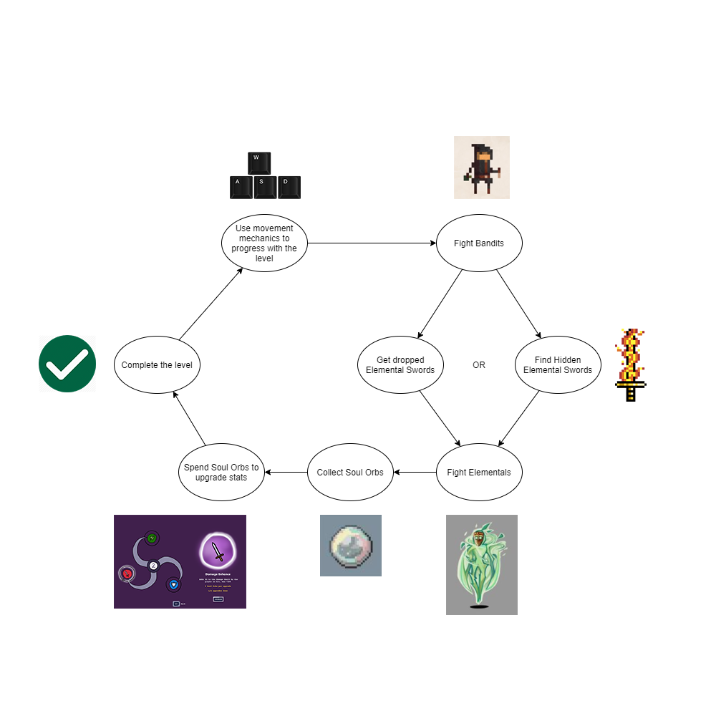

**Enemies:**

* Bandit
  + 100 HP
  + Deals 25 damage on hit
  + Might drop a sword upon death

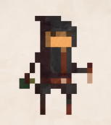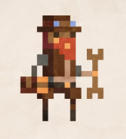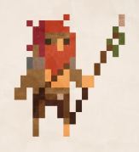

* Elemental
  + 4 kinds - Fire, Water, Earth, Air
  + 250 HP
  + Deals 50 damage on hit
  + Drops a Soul Orb upon death

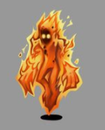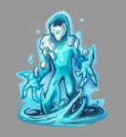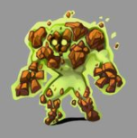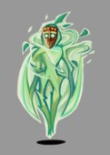

**Cutscenes:**

A short cutscene can be used between levels to introduce the element of the next level to the player (e.g. Fire Background)

**Inspiration board:**

<https://pin.it/N89VMK4>

**Mood boards**:

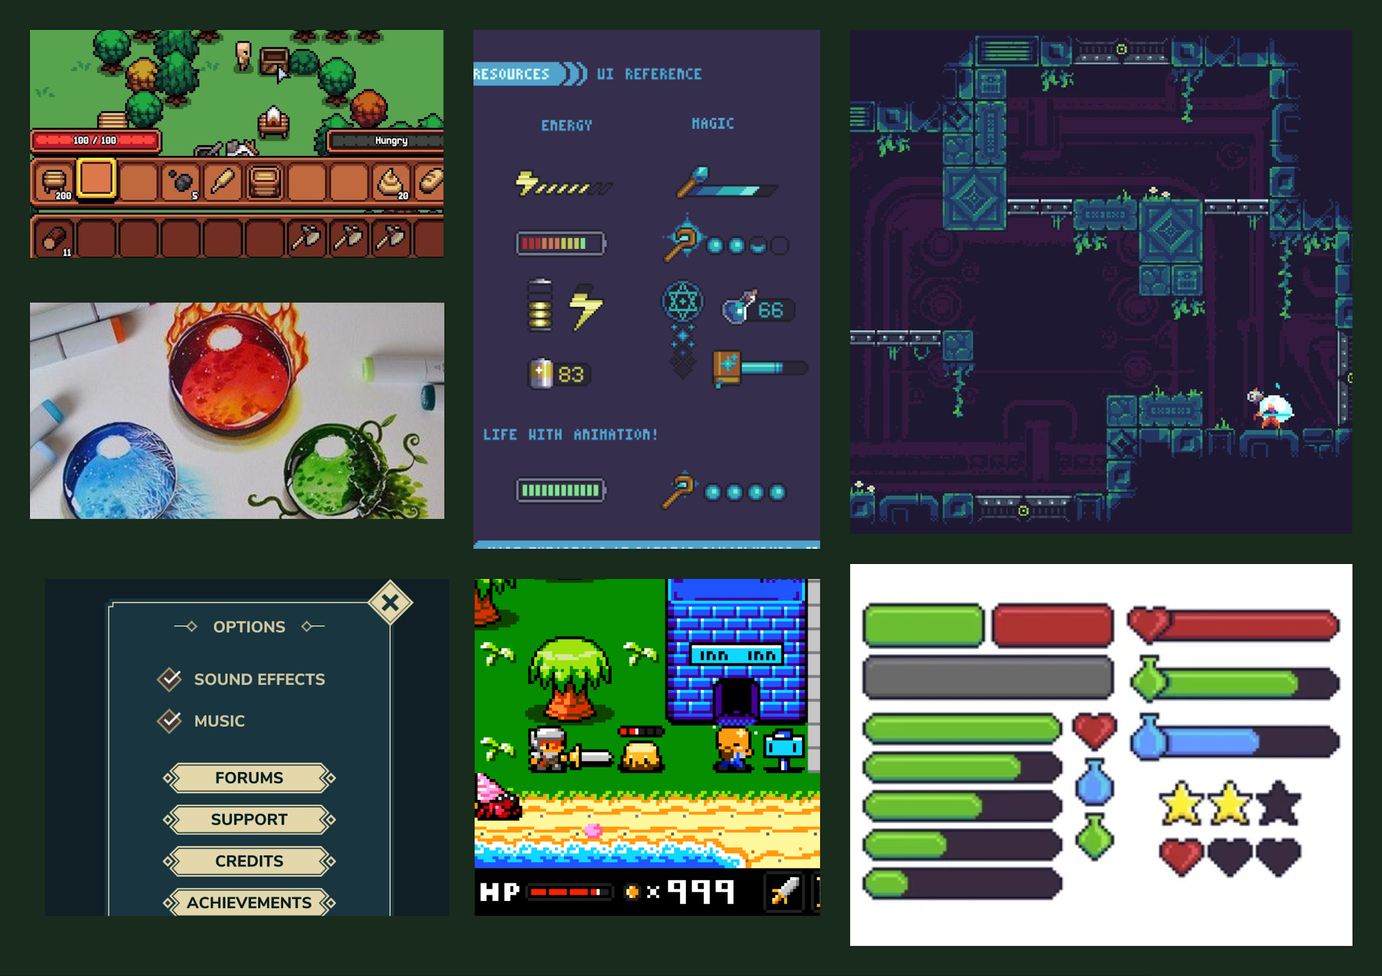

Functional art direction

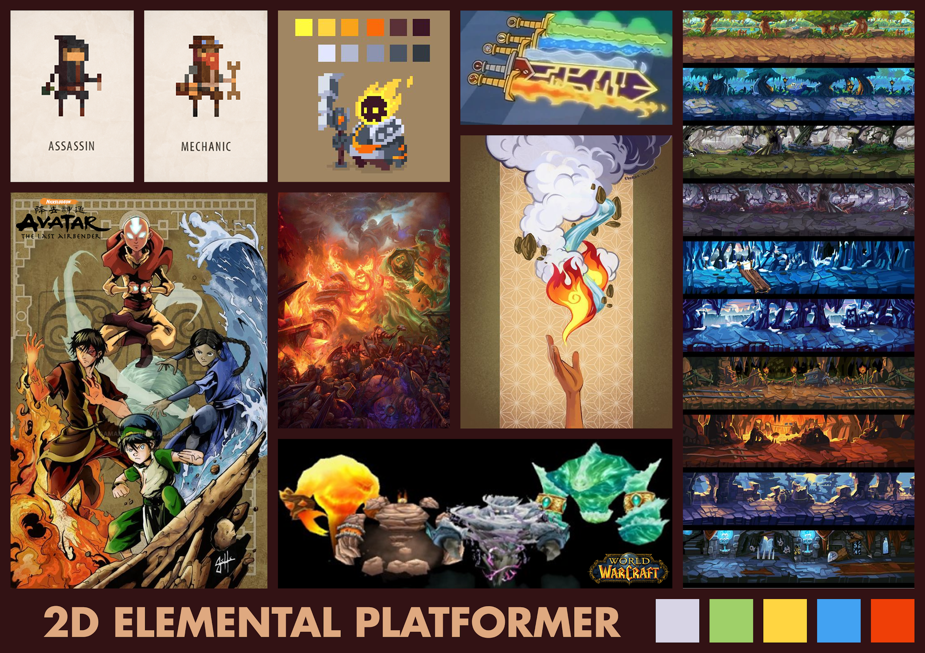

General art direction

**Excitement graphs:** 2 scenarios (excitement/time)

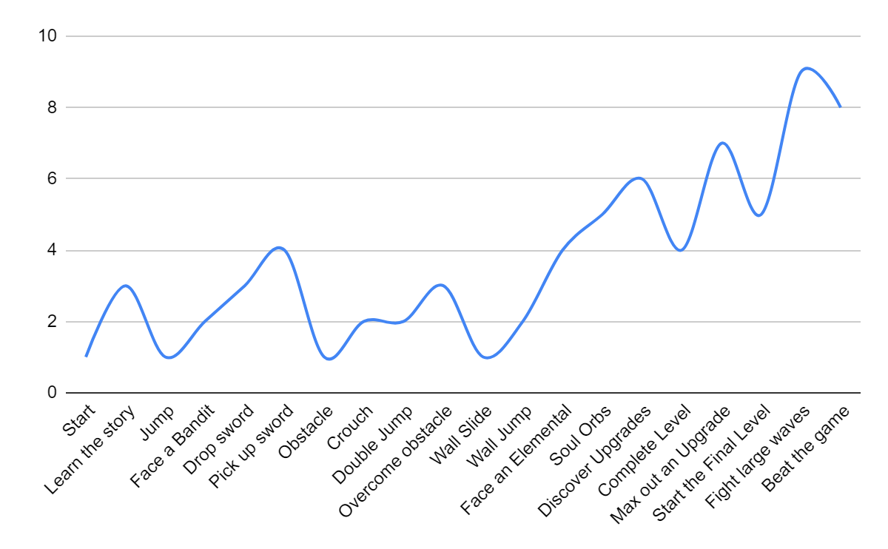

The player acquires a new sword after killing a Bandit

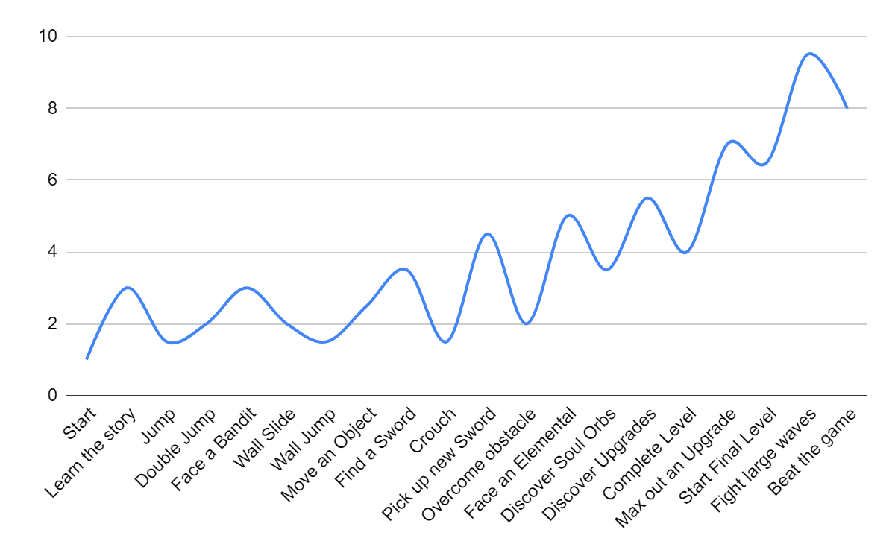

The player discovers new weapons after moving an object

**Extra links:**

Current playable build: <https://fontys-gdt.itch.io/thears-salvation>

Core mechanics video prototype: <https://youtu.be/tvdjrL_NPIc>

GitLab repository: <https://git.fhict.nl/I427262/s4-gdt-duo-project>